16_Discover_Share Chart (Vlookup)
Report Views
Standard View
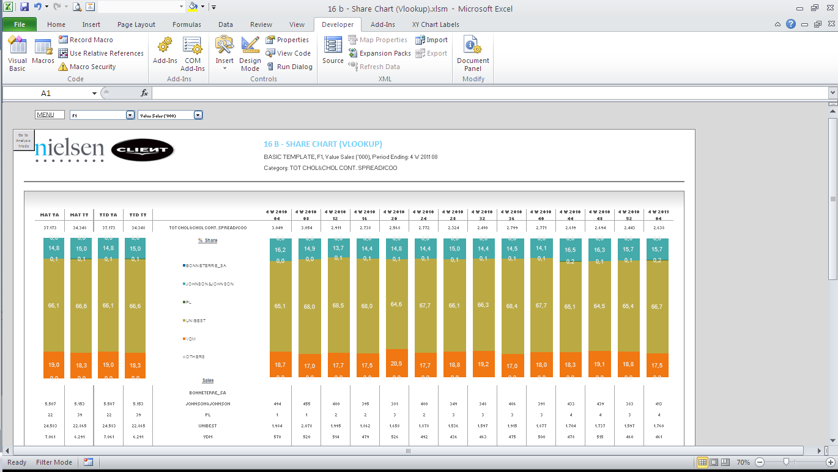

Standard View
Guidelines
Template Name | 16_Discover_Share Chart (Vlookup)
View Name | Standard View
Methodology | VLOOKUP
Default Dimension Order | Page Bar
Default Dimension Order | Columns | 1 Dimensions | Periods
Default Dimension Order | Rows | 1 Dimension | Markets, Facts, Products
Change dimension | - The dimensions can’t be swapped  - If a different layout is needed (for example, 2 dimensions on the columns) please select a different template  - The dimensions are following the Default Dimension order  - Dimension in Drop Down 1: First Position in Data set Rows  - Dimension in Drop Down 2: Second Position in Data set Rows  - Dimension in Row Table: Third Position in Data set Rows  - Dimension in Template Columns: in Data set Column
Data Selection Guidelines | Facts | - There is no limitation on facts, except the drop down list limitation, Facts should be Absolute sales, shares in the chart are calculated in the template based on the Absolute sales selected in the add-in.
Data Selection Guidelines | Products | - Maximum 25 products but must think about the layout of the chart, more than 18 will be unreadable.  - Product selection starts with the total Category followed by the products for the report (Major segment, Brands, or manufacturers).  - OTHERS will be calculated in the report
Data Selection Guidelines | Markets | - No limitation in number (except limitation on dropdown list)
Data Selection Guidelines | Periods | - 4 periods Maximum for Table or Chart at the left side, Maximum 14 periods Maximum for the table or Chart at the right side. These limitations are only due to layout, so all the report can fit in one page.
Data Selection Guidelines | NOTE: For the dimension in the Page Bar, the maximum number of items is 100  IMPORTANT:  - If report performance is poor, i.e., file opening and changing drop down selections take longer than several seconds (not acceptable by end user), remove any unused data rows from each Output Sheet, to improve user experience.  *Poor performance can be observed mostly in reports with multiple Output Sheets.  Example Scenario:  *Before removing rows, ensure you do not remove any important part of report configuration area.  RATIONALE: Individual cells in each row contain formulas, which need to be re-calculated every time a report is opened or drop down selection is changed. These additional operations, which run in the background, can negatively impact report performance, e.g., in a template with 40 formulas per row and 390 unused rows, the number of unnecessary operations is ~15600.
  Description | # Rows
  Default number of data rows handled by template | 500
  Number of items in rows (current report selection) | 60
  Buffer for any fluctuations in rows (deletions/additions of items in the future) | 50
  Unused number of data rows to be removed | 500-(60+50) = 390
To create a new report from this template | - Welcome Sheet – Check if the Configuration Area are filled in by the correct information.  - Output Sheet – Insert all the needed information on the first Row in the Parallel of the Table, if you add more Columns.  - Add or delete the needed columns to accommodate the retrieved information  - Never delete column outside the print Area.  - Depending on the number of periods, the table formatting and Charts will have to be adjusted.  - To make formatting easier, the existing formats can be copied  - When the new source Sheet is created, you have to run the following Macro: InsertColumns()

